**Defuse the Bomb – Basic Ratio and Proportion**

The Mathematician, a notorious terrorist has planted a bomb. You must defuse that bomb using the mathematical clues he’s left.

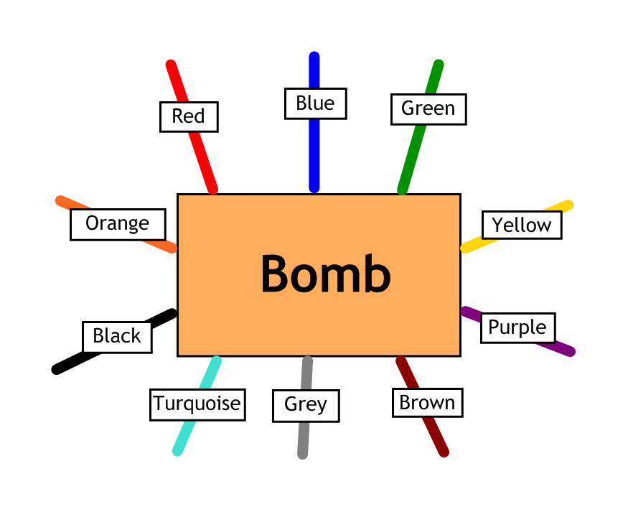

Answer the questions, then cut the coloured wires in the order that the answers appear, using the table below:

|  |  |  |  |  |  |  |  |  |  |
| --- | --- | --- | --- | --- | --- | --- | --- | --- | --- |
| Red | Blue | Green | Yellow | Purple | Brown | Grey | Turquoise | Black | Orange |
| 2:5 | 18 | 2:3 | 28 | 35 | 2:1 | 20 | 5:6 | 30 | 4:3 |

Here are the clues that show which order to cut the wires:

|  |  |
| --- | --- |
| 1 | In a class there are 10 boys and 15 girls. Write the ratio of boys to girls in its simplest form. 2:3 |
| 2 | The ratio of black beads to white beads on a necklace is 3:1. If there are 6 white beads on my necklace, how many black beads are there? 18 |
| 3 | Debbie has 24 ten pence pieces and 12 five pence pieces in her piggy bank. What is the ratio of 10p to 5p pieces in its simplest form? 2:1 |
| 4 | The ratio of adults to children on a picnic is 2:7. If there are 10 adults on the picnic, how many children are there? 35 |
| 5 | A recipe that makes enough cake for 8 people requires 200g of flour. How many people will a cake containing 700g of flour feed? 28 |
| 6 | A football team won 8 games and lost 6 games in a season. What is the ratio of games won to games lost in its simplest form? 4:3 |
| 7 | Adam is 9 years old and Billy is 11 years old. What will be the ratio of Adams’ age to Billy’s age in exactly one year’s time? Give your answer in its simplest form. 5:6 |
| 8 | It takes 4 workers 10 days to lay the foundations for a house. How long would it take 2 workers? 20 |